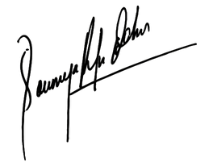

28/12/2003

Director

Soumya Behera

Certificate Date

Has successfully Completed Intensive 6 Months Software Testing Certification

Training and has completed all mandated course requirements and

industry projects with distinction.

SAHIL SONAR

THIS IS TO CERTIFY THAT

CERTIFICATE PROGRAM

Duration: Jul 2023 To Feb 2024

SOFTWARE TESTING

CERTIFICATE OF ACHIEVEMENT